OV (Organization Validation)
# Source: AI Source: Provided by: [Data Path: Persons Table -> ID Column: 1, Name_En Column: Motasem Essam] -> From: [ChatGPT] on [1/18/2026]
OV (Organization Validation) is a mid-level SSL/TLS certificate validation that verifies both domain ownership and the real organization behind the website. It provides more trust than DV, but with less friction than EV.

🔐 What OV (Organization Validation) Is
# Source: AI Source: Provided by: [Data Path: Persons Table -> ID Column: 1, Name_En Column: Motasem Essam] -> From: [ChatGPT] on [1/18/2026]
- Confirms domain ownership
- Verifies the legal existence of the organization
- Certificate includes company name and location
- Intended for business and organizational websites

🛠️ How OV Validation Works
# Source: AI Source: Provided by: [Data Path: Persons Table -> ID Column: 1, Name_En Column: Motasem Essam] -> From: [ChatGPT] on [1/18/2026]
The Certificate Authority (CA) checks:
- Domain control (DNS, email, or HTTP validation)
- Organization identity, including:
  - Legal business registration
  - Physical address
  - Phone number
- Operational existence (business is real and active)
Once verified → certificate is issued.
⏱️ Time to issue: Usually hours to a few days

📍 Where OV Certificates Are Used
# Source: AI Source: Provided by: [Data Path: Persons Table -> ID Column: 1, Name_En Column: Motasem Essam] -> From: [ChatGPT] on [1/18/2026]
- Business websites
- Corporate portals
- SaaS platforms
- Login pages
- APIs handling user data

✅ Advantages
# Source: AI Source: Provided by: [Data Path: Persons Table -> ID Column: 1, Name_En Column: Motasem Essam] -> From: [ChatGPT] on [1/18/2026]
- Higher trust than DV
- Shows verified company info in the certificate
- Reduces phishing risk
- Same strong encryption as EV

⚠️ Limitations
# Source: AI Source: Provided by: [Data Path: Persons Table -> ID Column: 1, Name_En Column: Motasem Essam] -> From: [ChatGPT] on [1/18/2026]
- Slower and more expensive than DV
- No strong browser UI indicators (modern browsers hide most details)
- Still less trusted than EV for high-risk transactions

🧠 OV vs DV vs EV (Quick View)
# Source: AI Source: Provided by: [Data Path: Persons Table -> ID Column: 1, Name_En Column: Motasem Essam] -> From: [ChatGPT] on [1/18/2026]
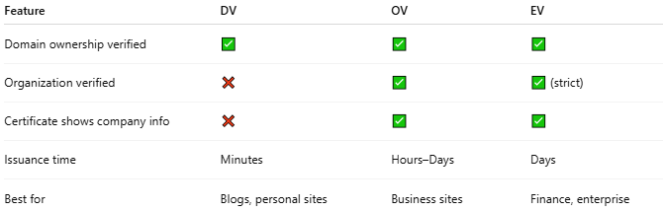
Feature | DV | OV | EV
Domain ownership verified | ✅ | ✅ | ✅
Organization verified | ❌ | ✅ | ✅ (strict)
Certificate shows company info | ❌ | ✅ | ✅
Issuance time | Minutes | Hours–Days | Days
Best for | Blogs, personal sites | Business sites | Finance, enterprise

🔒 Security Note
# Source: AI Source: Provided by: [Data Path: Persons Table -> ID Column: 1, Name_En Column: Motasem Essam] -> From: [ChatGPT] on [1/18/2026]
🔐 Encryption strength is identical for DV, OV, and EV.
The difference is identity verification, not security level.

One-sentence summary
# Source: AI Source: Provided by: [Data Path: Persons Table -> ID Column: 1, Name_En Column: Motasem Essam] -> From: [ChatGPT] on [1/18/2026]
OV certificates verify the organization behind a domain and provide more trust than DV, making them ideal for business websites.

